**Impact of COVID-19 on Travel (CSCI E-101 Thanksgiving Challenge)**

Ashwin Pillai, Syukri Shukor, Teena Thankachan

**Graphs**

**Figure 1**

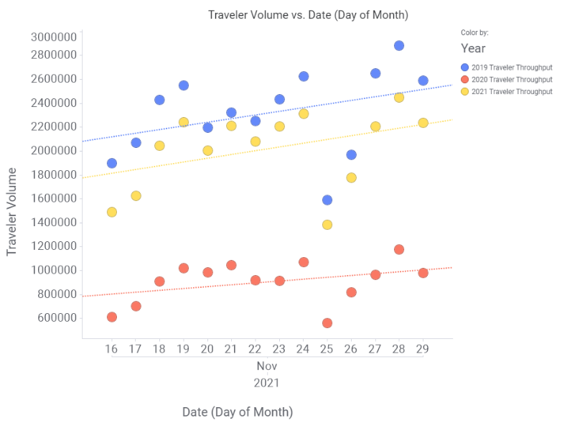

**Figure 1** plots daily TSA traveler volume in 2019, 2020, and 2021 (Spotfire)

Figure 2

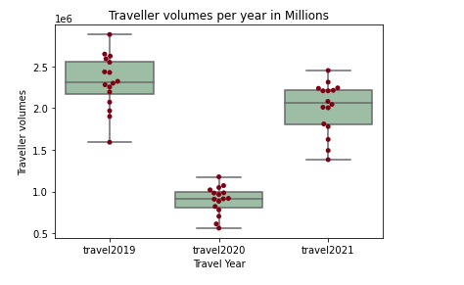

**Figure 2** shows box plots for average daily TSA traveler volume in 2019, 2020, and 2021.

**Extra Thoughts**

Finding data is hard. Our dataset using only the last 3 years of TSA released data does not give us a truly full picture of the average of Thanksgiving travel. We are comparing 1 year of normal travel to 1 year of no travel (peak covid) to 1 year of potentially normal travel. In searching for richer datasets we found many articles that their numbers were pulled from other articles themselves (NBC -> CNBC). When digging deeper the data always ended up at a company such as Cuebiq (<https://www.cuebiq.com/>) or Statista which require payment for data. Or AAA which has their own internal data sets collected from bookings, along with companies such as Kayak and Priceline who release trends from their data but not their own data

In trying to be creative we looked at google search history as well (not high confidence in this) but interesting to see, and is available for free (<https://trends.google.com/trends/explore?date=all&geo=US&q=flight%20to>) google searches in January saying “flight to” followed the trend of increasing flights year over year. Dropped in November of 2020 but recovered significantly in 2021. This is by no means a significant test but gives a quick glance at a larger dataset.

